Ideation Phase

Define the Problem Statements

|  |  |
| --- | --- |
| Date | 09-09-2022 |
| Team ID | PNT2022TMID30061 |
| Project Name | Nutrition Assistant Application |
| Maximum Marks | 2 Marks |

# Customer Problem Statement Template:

Create a problem statement to understand your customer's point of view. The Customer Problem Statement template helps you focus on what matters to create experiences people will love.

A well-articulated customer problem statement allows you and your team to find the ideal solution for the challenges your customers face. Throughout the process, you’ll also be able to empathize with your customers, which helps you better understand how they perceive your product or service.

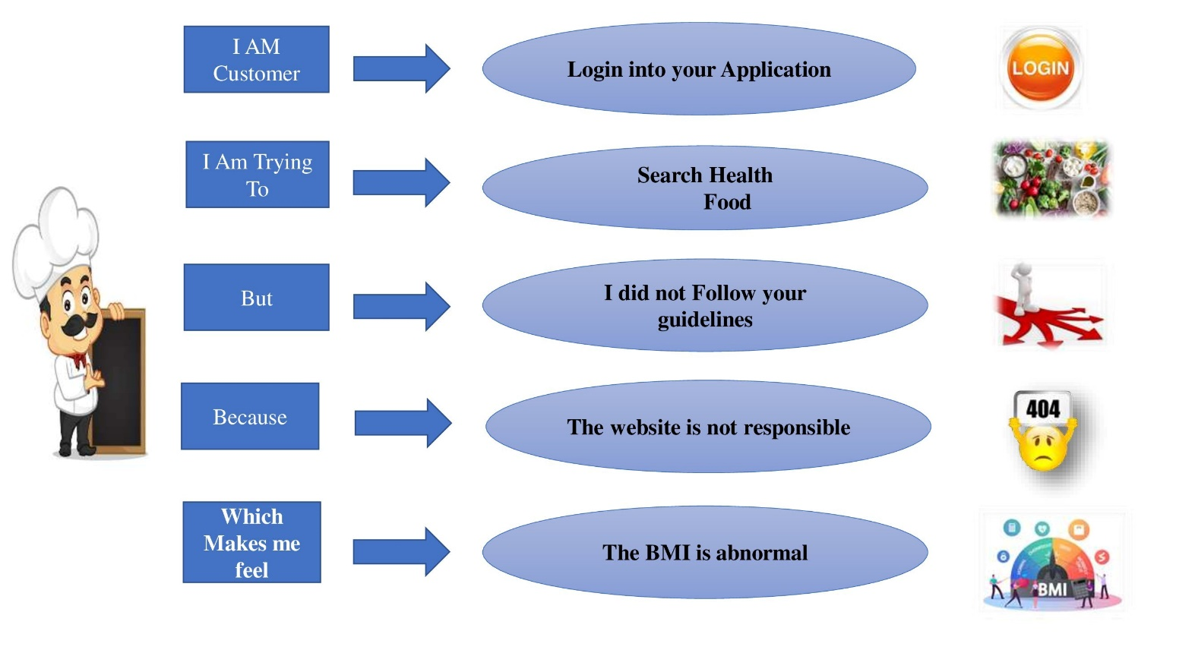

**Example**:

|  |  |  |  |  |  |
| --- | --- | --- | --- | --- | --- |
| **Problem**  **Statement (PS)** | **I am**  **(Customer)** | **I’m trying to** | **But** | **Because** | **Which makes me feel** |
| PS-1 | Login into your Application | Search Health  Food | I did not Follow your guidelines | The website is not responsible | The BMI is abnormal |
| PS-2 | Login into your website | Doctor consultancy | Appointment date is expired | The website is not working | Unhealthy |
| PS-3 | Login into your application | Users trying to offline mode | Less features | Network not Available | Not happy |